**BC547**

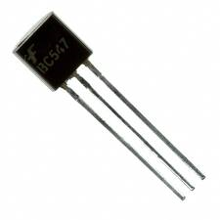

BC547 is an NPN bi-polar junction transistor. A transistor, stands for transfer of resistance, is commonly used to amplify current. A small current at its base controls a larger current at collector & emitter terminals.

  BC547 is mainly used for amplification and switching purposes. It has a maximum current gain of 800. Its equivalent transistors are BC548 and BC549.

The transistor terminals require a fixed DC voltage to operate in the desired region of its characteristic curves. This is known as the biasing. For amplification applications, the transistor is biased such that it is partly on for all input conditions. The input signal at base is amplified and taken at the emitter. BC547 is used in common emitter configuration for amplifiers. The voltage divider is the commonly used biasing mode. For switching applications, transistor is biased so that it remains fully on if there is a signal at its base. In the absence of base signal, it gets completely off.

**Pin Diagram:**

